**TRANSACTION FRAUD ANALYSIS**

# Overview

This project focuses on analyzing transactional data for fraud detection and customer value assessment. Significant tables include Financial Data, Merchant Details, Customer Data, and Card Details. Tools used include Python for data processing, SQL for querying and relational database management, and Power BI for interactive data visualization and insights. The goal is to enhance fraud detection and identify high-value customers.

# Dataset Overview

**1. Financial Data**

* **Columns**: transaction_id, customer_id, merchant_id, amount, is_fraudulent, card_ID, CLV, location_ID
* **Description**: Contains transaction records including customer IDs, merchant IDs, transaction amounts, fraud indicators, card details, customer lifetime value (CLV), and corresponding location IDs. This data is crucial for analyzing patterns in fraudulent activities.

**2. Customer Details**

* **Columns**: customer_id, Customer_Age, Account_Tenure_Years, Transaction_Frequency
* **Description**: Contains information about customers, including their age, how long they have had their accounts, and their transaction frequency. These attributes help in understanding customer behavior and assessing risk factors related to fraud.

**3. Merchant Details**

* **Columns**: merchant_id, purchase_category
* **Description**: Lists merchants and their associated purchase categories. This data aids in analyzing transaction types and potential fraud hotspots based on merchant categories.

**4. Location Details**

* **Columns**: location_ID, City, Country
* **Description**: Contains unique city names and their respective countries, providing geographical context to the transactions. This helps in regional analysis of fraud patterns and customer demographics.

**5. Card Details**

* **Columns**: card_ID, card_type
* **Description**: Includes card IDs and their corresponding types. This data can be used to evaluate fraud trends based on different card types, offering insights into vulnerabilities associated with specific cards.

# Analysis in SQL

***Database Diagram***

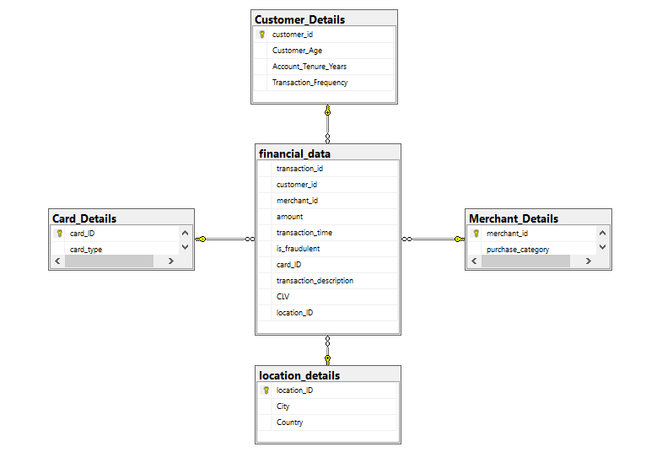

***-- Developing an index on the customer_id and merchant_id within the financial_data table***

CREATE INDEX idx_customer_merchant

ON financial_data (customer_id, merchant_id);

***-- 1. Calculating Average Transaction Amount per Merchant***

With AvgAmountPerMerchant as (

Select merchant_id,AVG(amount) as avg_amount

from financial_data

group by merchant_id

)

select merchant_id, avg_amount

from AvgAmountPerMerchant

order by avg_amount desc;

***-- 2. Retrieving Cities with the Highest CLV (Customer Lifetime Value) for Fraudulent Transactions***

select top 10 ld.City, AVG(fd.CLV) as Average_CLV

from financial_data fd

JOIN location_details ld on fd.location_ID = ld.location_ID

where fd.is_fraudulent = 1

group by ld.City

order by Average_CLV desc;

***-- 3. Finding top Merchants with the Most Fraudulent Transactions***

select top 5 merchant_id, COUNT(*) as fraudulent_transaction_count

from financial_data

where is_fraudulent = 1

group by merchant_id

order by fraudulent_transaction_count desc;

***-- 4. Showing top 10 Customers by total Transaction Amount***

select distinct top 10

customer_id,

round(sum(amount) over (partition by customer_id), 2) as total_transaction_amount

from financial_data

order by total_transaction_amount desc;

***-- 5. Categorizing the transactions by amount***

select customer_id,

count(*) as transaction_count,

sum(amount) as total_amount,

CASE

When sum(amount) < 100000 then 'Low Value'

When sum(amount) between 100000 and 500000 then 'Medium Value'

When sum(amount) > 500000 then 'High Value'

ELSE 'Unknown'

end as transaction_value_category

from financial_data

group by customer_id

order by total_amount desc;

***-- 6. Customers with the transactions at Merchants related to "shopping" or "retail"***

select distinct customer_id

from financial_data

where merchant_id IN (

select merchant_id

from merchant_details

where purchase_category LIKE '%Shopping%' or purchase_category LIKE '%Retail%'

);

***-- 7. Recognizing top Countries with the most fraudulent transactions***

select ld.Country,

count(fd.transaction_id) as fraud_count,

round(SUM(fd.amount),2) as total_fraud_amount

from financial_data fd

JOIN location_details ld

ON fd.location_ID = ld.location_ID

where fd.is_fraudulent = 1

group by ld.Country

order by fraud_count desc;

# Analysis in Python

***1. Counts of different types transactions***

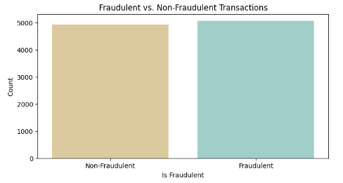

***2. Distribution of the transactions***

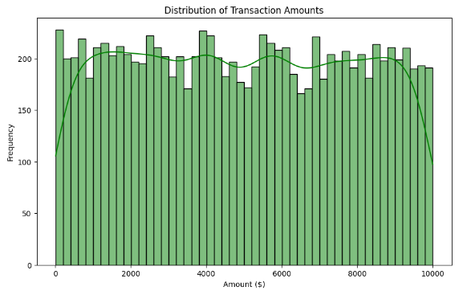

***3. Transactions by card type***

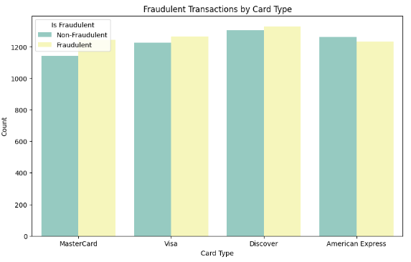

***4. Distribution of CLV***

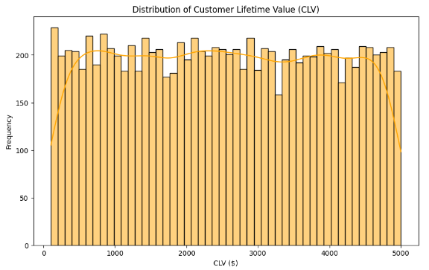

***5. Correlation Heatmap***

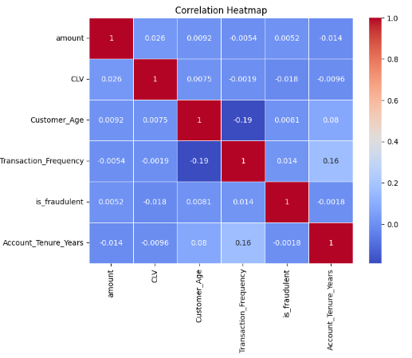

***6. Fraudulent Transactions by Curchase Category***

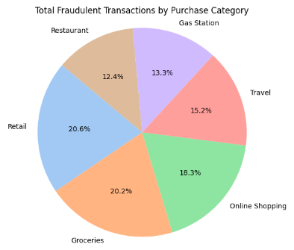

***7. Transactions by top 10 cities***

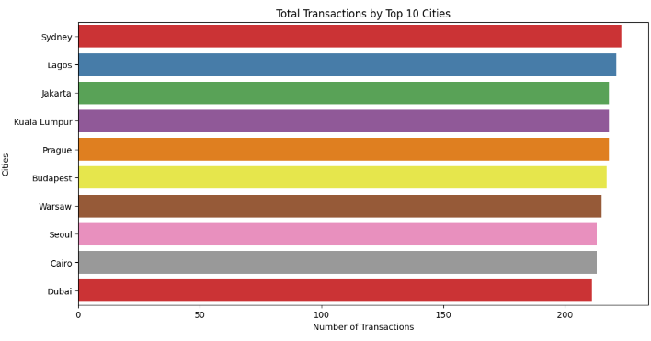

***8. Boxplot for Transaction_Frequency***

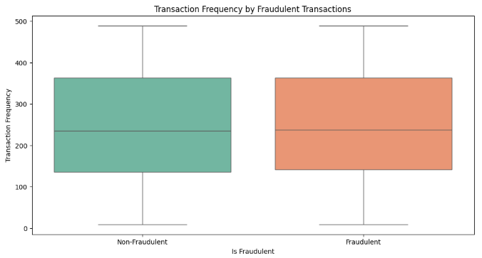

# Analysis in Power BI

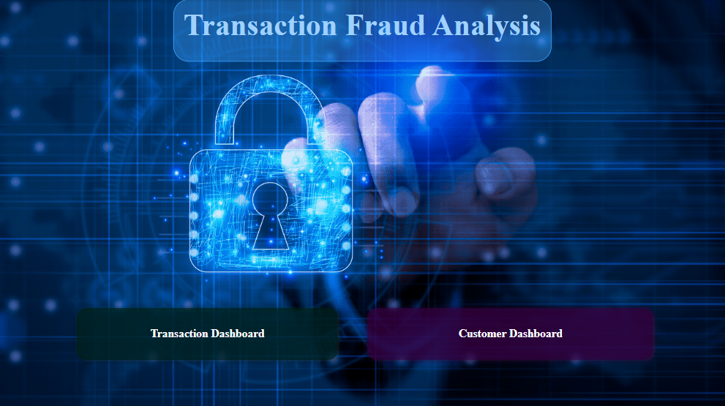  
Home Page

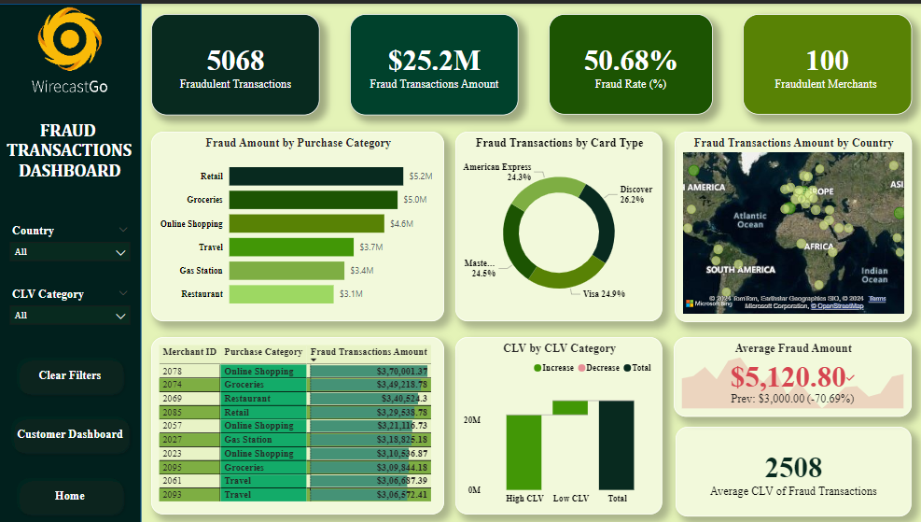

Fraud Transaction Dashboard

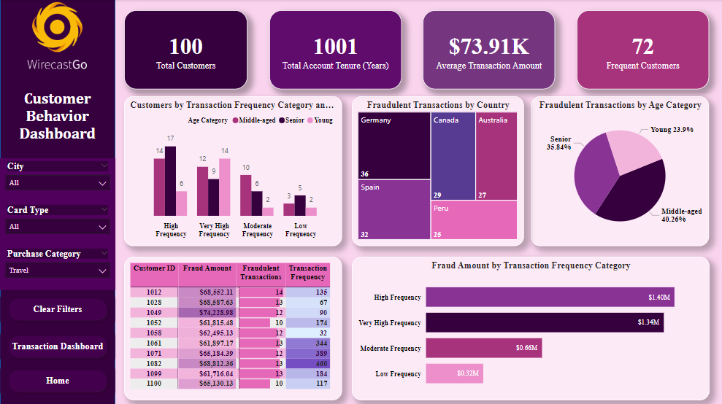

Customer Insights Dashboard